Q1. Design a calculator in android mobile programming

Main_Activity.xml

<LinearLayout
xmlns:android="http://schemas.android.com/apk/res/android"
xmlns:tools="http://schemas.android.com/tools"
android:layout_width="match_parent"
android:layout_height="match_parent"
android:orientation="vertical"
android:padding="16dp"
android:background="#F5F5F5"
tools:context=".MainActivity">

<EditText
android:id="@+id/number1"
android:layout_width="match_parent"
android:layout_height="wrap_content"
android:inputType="numberDecimal|numberSigned"
android:hint="Enter first number"
android:textSize="18sp"
android:padding="12dp"
android:layout_marginBottom="8dp"
android:background="@android:color/white"
android:elevation="2dp" />

<EditText
android:id="@+id/number2"
android:layout_width="match_parent"
android:layout_height="wrap_content"
android:inputType="numberDecimal|numberSigned"
android:hint="Enter second number"
android:textSize="18sp"
android:padding="12dp"
android:layout_marginBottom="16dp"
android:background="@android:color/white"
android:elevation="2dp" />

<LinearLayout
android:layout_width="match_parent"
android:layout_height="wrap_content"
android:orientation="horizontal"
android:layout_marginBottom="16dp">

<Button
android:id="@+id/addButton"
android:layout_width="0dp"
android:layout_height="wrap_content"
android:layout_weight="1"
android:layout_margin="4dp"
android:text="+"
android:textSize="20sp" />

<Button
android:id="@+id/subtractButton"
android:layout_width="0dp"
android:layout_height="wrap_content"
android:layout_weight="1"
android:layout_margin="4dp"
android:text="-"
android:textSize="20sp" />

<Button
android:id="@+id/multiplyButton"
android:layout_width="0dp"
android:layout_height="wrap_content"
android:layout_weight="1"
android:layout_margin="4dp"
android:text="×"
android:textSize="20sp" />

<Button
android:id="@+id/divideButton"
android:layout_width="0dp"
android:layout_height="wrap_content"
android:layout_weight="1"
android:layout_margin="4dp"
android:text="÷"
android:textSize="20sp" />
</LinearLayout>

<TextView
android:id="@+id/result"
android:layout_width="match_parent"
android:layout_height="wrap_content"
android:textSize="28sp"
android:textStyle="bold"
android:textColor="#212121"
android:padding="16dp"
android:background="@android:color/white"
android:elevation="2dp"
android:gravity="center"
android:text="Result: 0" />

</LinearLayout>

Main_Activity.java
import androidx.appcompat.app.AppCompatActivity;
import android.os.Bundle;
import android.view.View;
import android.widget.Button;
import android.widget.EditText;
import android.widget.TextView;
import android.widget.Toast;

public class MainActivity extends AppCompatActivity {

private EditText number1, number2;
private TextView result;

@Override
protected void onCreate(Bundle savedInstanceState) {
super.onCreate(savedInstanceState);
setContentView(R.layout.activity_main);

// Initialize views
number1 = findViewById(R.id.number1);
number2 = findViewById(R.id.number2);
result = findViewById(R.id.result);

// Set up button listeners
findViewById(R.id.addButton).setOnClickListener(v -> performOperation(Operation.ADD));
findViewById(R.id.subtractButton).setOnClickListener(v -> performOperation(Operation.SUBTRACT));
findViewById(R.id.multiplyButton).setOnClickListener(v -> performOperation(Operation.MULTIPLY));
findViewById(R.id.divideButton).setOnClickListener(v -> performOperation(Operation.DIVIDE));
}

private enum Operation {
ADD, SUBTRACT, MULTIPLY, DIVIDE
}

private void performOperation(Operation operation) {
// Validate input
if (!validateInput()) {
return;
}

double num1 = Double.parseDouble(number1.getText().toString());
double num2 = Double.parseDouble(number2.getText().toString());
double res;

try {
switch (operation) {
case ADD:
res = num1 + num2;
break;
case SUBTRACT:
res = num1 - num2;
break;
case MULTIPLY:
res = num1 * num2;
break;
case DIVIDE:
if (num2 == 0) {
showError("Cannot divide by zero");
return;
}
res = num1 / num2;
break;
default:
return;
}

// Format result to avoid excessive decimal places
String formattedResult = String.format("Result: %.2f", res);
result.setText(formattedResult);

} catch (Exception e) {
showError("Calculation error: " + e.getMessage());
}
}

private boolean validateInput() {
String input1 = number1.getText().toString().trim();
String input2 = number2.getText().toString().trim();

if (input1.isEmpty() || input2.isEmpty()) {
showError("Please enter both numbers");
return false;
}

try {
Double.parseDouble(input1);
Double.parseDouble(input2);
return true;
} catch (NumberFormatException e) {
showError("Please enter valid numbers");
return false;
}
}

private void showError(String message) {
Toast.makeText(this, message, Toast.LENGTH_SHORT).show();
result.setText("Result: Error");
}
}

PRACTICAL 2
Programming Resources
Android Resources: (Color, Theme, String, Drawable, Dimension, Image).
Color:
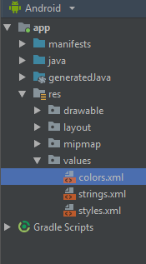
Color.xml
<?xml version="1.0" encoding="utf-8"?>
<resources>
<color name="colorPrimary">#008577</color>
<color name="colorPrimaryDark">#00574B</color>
<color name="colorAccent">#D81B60</color>
</resources>

Theme:
Style.xml
<resources>
<!-- Base application theme. -->
<style name="AppTheme" parent="Theme.AppCompat.Light.DarkActionBar">
<!-- Customize your theme here. -->
<item name="colorPrimary">@color/colorPrimary</item>
<item name="colorPrimaryDark">@color/colorPrimaryDark</item>
<item name="colorAccent">@color/colorAccent</item>
</style>
</resources>

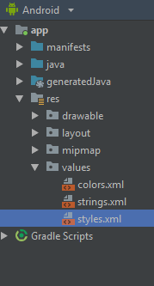

String:
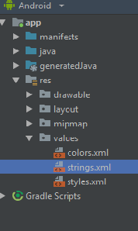
String.xml:
<resources>
<string name="app_name">hello</string>
<string name="numbers">
<item>1</item>
<item>2</item>
<item>3</item>
</item>
</string>
</resources>

Drawable:
- Right click on drawable folder
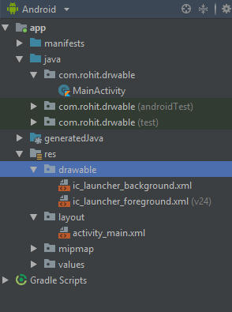
- Copy the image if you want to create image drawable
- Paste that image file inside the drawable folder
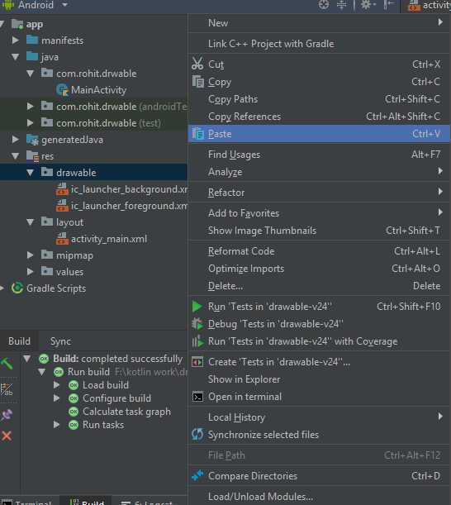

Note: to create drawable resource, right click on drawable folder and select drawable resource file.

Dimension, Image:
Main_Activity.kt:
package com.rohit.drwable
import android.support.v7.app.AppCompatActivity
import android.os.Bundle
class MainActivity : AppCompatActivity() {
override fun onCreate(savedInstanceState: Bundle?) {
super.onCreate(savedInstanceState)
setContentView(R.layout.activity_main)
}
}

activity_main.xml:
<?xml version="1.0" encoding="utf-8"?>
<LinearLayout
xmlns:android="http://schemas.android.com/apk/res/android"
xmlns:tools="http://schemas.android.com/tools"
xmlns:app="http://schemas.android.com/apk/res-auto"
android:layout_width="match_parent"
android:layout_height="match_parent"
tools:context=".MainActivity"
android:background="@drawable/one">
<TextView
android:layout_width="wrap_content"
android:layout_height="wrap_content"
android:text="Hello World!"
app:layout_constraintBottom_toBottomOf="parent"
app:layout_constraintLeft_toLeftOf="parent"
app:layout_constraintRight_toRightOf="parent"
app:layout_constraintTop_toTopOf="parent"/>
</LinearLayout>
Output:
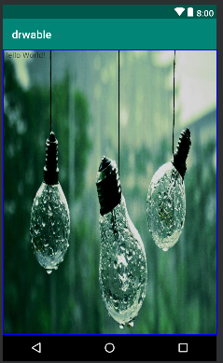

PRACTICAL 3
Programming Activities and fragments
Activity Life Cycle, Activity methods, Multiple Activities, Life Cycle of fragments and multiple fragments.

Activity Lifecycle:
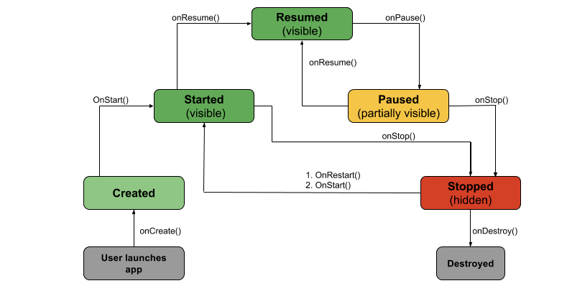
- onCreate(): Called by the OS when the activity is first created. This is where you initialize any UI elements or data objects. You also have the savedInstanceState of the activity that contains its previously saved state, and you can use it to recreate that state.\

fun onCreate(savedInstanceState: Bundle?) {
super.onCreate(savedInstanceState)
setContentView(R.layout.activity_task_description)

- onStart(): Just before presenting the user with an activity, this method is called. It’s always followed by onResume(). In here, you generally should start UI animations, audio based content or anything else that requires the activity’s contents to be on screen.

- onResume(): As an activity enters the foreground, this method is called. Here you have a good place to restart animations, update UI elements, restart camera previews, resume audio/video playback or initialize any components that you release during onPause().
- onPause(): This method is called before sliding into the background. Here you should stop any visuals or audio associated with the activity such as UI animations, music playback or the camera. This method is followed by onResume() if the activity returns to the foreground or by onStop() if it becomes hidden.

- onStop(): This method is called right after onPause(), when the activity is no longer visible to the user, and it’s a good place to save data that you want to commit to the disk. It’s followed by either onRestart(), if this activity is coming back to the foreground, or onDestroy() if it’s being released from memory.

- onRestart(): Called after stopping an activity, but just before starting it again. It’s always followed by onStart().

- onDestroy(): This is the final callback you’ll receive from the OS before the activity is destroyed. You can trigger an activity’s desctruction by calling finish(), or it can be triggered by the system when the system needs to recoup memory. If your activity includes any background threads or other long-running resources, destruction could lead to a memory leak if they’re not released, so you need to remember to stop these processes here as well.

EXAMPLE:
import android.os.Bundle
import android.support.design.widget.Snackbar
import android.support.v7.app.AppCompatActivity
import android.view.Menu
import android.view.MenuItem
import android.util.Log
import kotlinx.android.synthetic.main.activity_state_change.*
class StateChangeActivity : AppCompatActivity() {
val TAG = "StateChange"
override fun onCreate(savedInstanceState: Bundle?) {
super.onCreate(savedInstanceState)
setContentView(R.layout.activity_state_change)
setSupportActionBar(toolbar)
fab.setOnClickListener { view ->
Snackbar.make(view, "Replace with your own action",
Snackbar.LENGTH_LONG)
.setAction("Action", null).show()
}
Log.i(TAG, "onCreate")
}
}
override fun onStart() {
super.onStart()
Log.i(TAG, "onStart")
}
override fun onResume() {
super.onResume()
Log.i(TAG, "onResume")
}
override fun onPause() {
super.onPause()
Log.i(TAG, "onPause")
}
override fun onStop() {
super.onStop()
Log.i(TAG, "onStop")
}
override fun onRestart() {
super.onRestart()
Log.i(TAG, "onRestart")
}
override fun onDestroy() {
super.onDestroy()
Log.i(TAG, "onDestroy")
}
override fun onSaveInstanceState(outState: Bundle?) {
super.onSaveInstanceState(outState)
Log.i(TAG, "onSaveInstanceState")
}
override fun onRestoreInstanceState(savedInstanceState: Bundle?) {
super.onRestoreInstanceState(savedInstanceState)
Log.i(TAG, "onRestoreInstanceState")
}

Multiple Activities:
activity_first.xml code:
<?xml version="1.0" encoding="utf-8"?>
<RelativeLayout
xmlns:android="http://schemas.android.com/apk/res/android"
xmlns:tools="http://schemas.android.com/tools"
xmlns:app="http://schemas.android.com/apk/res-auto"
android:layout_width="match_parent"
android:layout_height="match_parent"
tools:context="ganeshannt.frist.FristActivity">
<Button
android:id="@+id/button2"
android:layout_width="wrap_content"
android:layout_height="wrap_content"
android:onClick="Ganesh"
android:text="click third activity"
android:textColor="@color/colorPrimary"
app:layout_constraintTop_toTopOf="parent"
tools:layout_editor_absoluteX="168dp"
android:layout_alignParentBottom="true"
android:layout_toEndOf="@+id/text"
android:layout_marginBottom="196dp" />
<TextView
android:layout_width="wrap_content"
android:layout_height="wrap_content"
android:text="This s my first app!"
android:id="@+id/text"
tools:layout_editor_absoluteY="8dp"
tools:layout_editor_absoluteX="8dp" />
<Button
android:layout_width="wrap_content"
android:layout_height="wrap_content"
android:id="@+id/button"
android:text="click second activity"
android:textColor="@color/colorPrimary"
android:onClick="Ganesh"
tools:layout_editor_absoluteX="168dp"
app:layout_constraintTop_toTopOf="parent"
android:layout_above="@+id/button2"
android:layout_alignStart="@+id/button2"
android:layout_marginBottom="40dp" />
</RelativeLayout>

activity_second.xml code:
<?xml version="1.0" encoding="utf-8"?>
<LinearLayout xmlns:android="http://schemas.android.com/apk/res/android"
android:orientation="vertical" android:layout_width="match_parent"
android:layout_height="match_parent">
<TextView
android:layout_width="wrap_content"
android:layout_height="wrap_content"
android:layout_margin="20pt"
android:text="second acticity is working...."
android:textAllCaps="true"
android:textColor="@color/colorPrimaryDark"/>
</LinearLayout>

activity_third.xml code:
<?xml version="1.0" encoding="utf-8"?>
<LinearLayout xmlns:android="http://schemas.android.com/apk/res/android"
android:orientation="vertical" android:layout_width="match_parent"
android:layout_height="match_parent">
<TextView
android:layout_width="wrap_content"
android:layout_height="wrap_content"
android:layout_margin="20pt"
android:text="Third activity is working ........."
android:textAllCaps="true"
android:textColor="@color/colorPrimary"
/>
</LinearLayout>

Activity_first.kt
package rohit.technobeat
import android.content.Intent
import android.support.v7.app.AppCompatActivity
import android.os.Bundle
import kotlinx.android.synthetic.main.activity_login.*
import kotlinx.android.synthetic.main.activity_main.*
import kotlinx.android.synthetic.main.activity_register.*
import rohit.technobeat.R.id.login
import rohit.technobeat.R.id.newaccount
class MainActivity : AppCompatActivity() {
override fun onCreate(savedInstanceState: Bundle?) {
super.onCreate(savedInstanceState)
setContentView(R.layout.activity_main)
second.setOnClickListener {
val intent = Intent(this, Activity_second::class.java)
// start your next activity
startActivity(intent)
}
third.setOnClickListener {
val intent = Intent(this, Activity_third::class.java)
// start your next activity
startActivity(intent)
}
}
}

